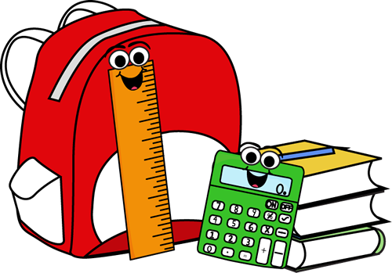

NMES Grade Two -English and Immersion
School Supply List 2021-22

- A $45.00 supply fee to cover supplies that can be colour-coded and organized for each student. ASD-W’s preferred form of payment is through SchoolCash Online. You are able to register – a simple task that takes less than 2 minutes by visiting https://www.schoolcashonline.com/ or visiting our website at http://web1.nbed.nb.ca/sites/ASD-W/NMES/Pages/default.aspx and navigating your way to the SchoolCash Online on the right hand side of the screen.
- 1 box of Kleenex.
- Indoor sneakers (please purchase sneakers that will allow your child to participate in gym safely – they should be able to be fully tied or fastened).
- 1 USB (Can use last year’s)

Other Suggested Items:
- A sturdy reusable water bottle.
- A change of clothes including socks, underwear, pants and a shirt in the case of a playground incident.

Have a safe summer!

NMES Grade 2 Teachers

